|  |  |
| --- | --- |
| Project Name | Smart farmer-IOT Enabled smart farming  application |

AN ACCOUNT WAS CREATED IN MIT APP INVENTOR AND FEATURES WERE OVERVIEWED

DESIGNER

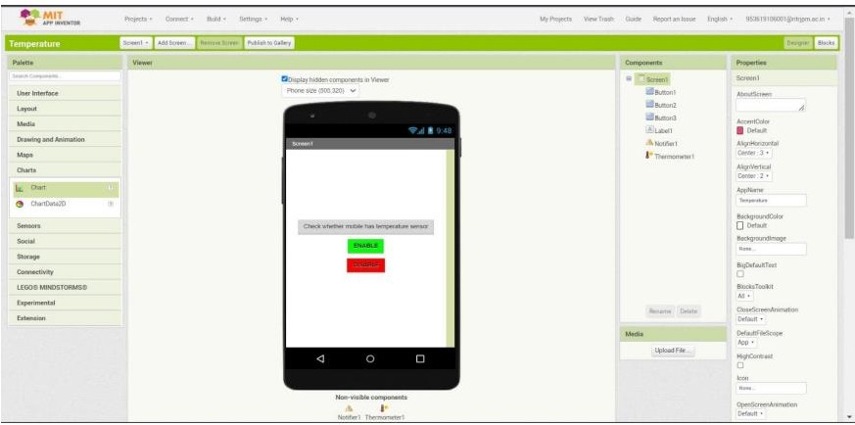

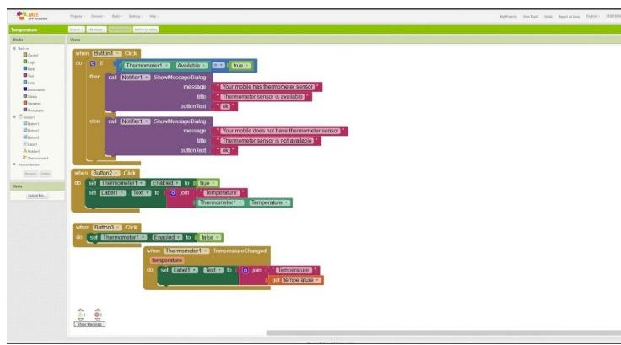BLOCK